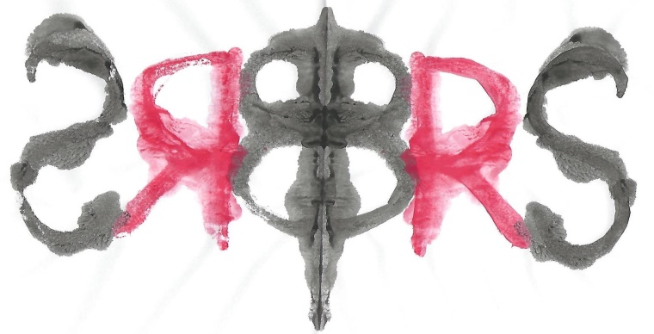

The British Society for the Rorschach
and Projective Methods
Invites you to our

Two-Part Annual Case Seminar

Friday 20th October 2023 2pm to 4pm (BST)
And
Friday 1st December 2023 2pm to 4pm (BST)

The same case will be presented over two sessions; the first one will focus on scoring the protocol and the second meeting will focus on the interpretation of the same protocol. The Comprehensive System will be used for both scoring and interpretation and comparisons with the new Comprehensive System-Revised will be made.

This case presentation will provide an opportunity to discuss how the Rorschach data contributes to the formulation and understanding of the examinee’s personality functioning in the light of the referral question. It will also provide participants a good introduction to the Comprehensive System-Revised. Dr Kari Carstairs will lead both sessions.

This event is free for all members of the British Society for the Rorschach and Projective Methods. Non-members are very welcome to join us and will be asked to pay £20 per person per session or £30 for both sessions. The number of places is limited to eight participants. The protocol will be sent out by 6th October to give participants 2 weeks to score it themselves and then bring their questions to the workshop.

Please contact Dr Carstairs to confirm your attendance.

Any questions and for registration, contact Dr Carstairs at kari@carstairspsych.co.uk

