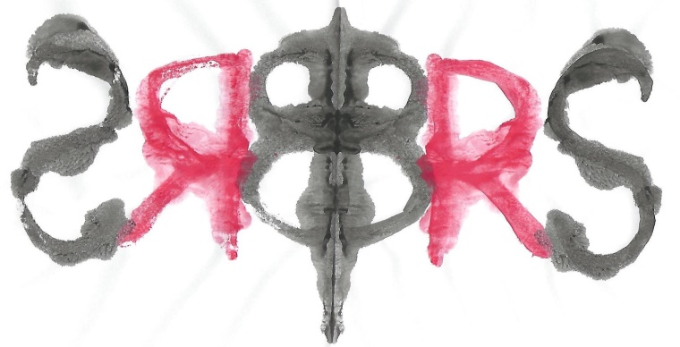

The British Rorschach Society
Invites you to our

Comprehensive System
Rorschach Scoring workshop
With Dr Kari Carstairs

One case from the database of the 88 participants from our normative study will be selected and the group will go through the scoring for that protocol in the session.
All cases from the normative study have been through a rigorous scoring procedure. The psychologist who administered the test scored it first, then another psychologist from the five of us who provided the data for the study scored it and any differences between the two were then reviewed and a consensus was reached. Then all of the protocols were scored again by Anne Andronikof and any differences between her scoring and ours were subject to discussion between her and me to arrive at a final, agreed scoring. Lastly, one quarter of the protocols were scored yet again by Patrick Fontan for a reliability study, the outcome of which demonstrated excellent inter-scorer reliability.

The verbatim responses and location sheet will be sent out in advance to everyone who wants to take part and you can then have a go at doing the scoring yourselves. We will then "meet" over Zoom for a discussion of the scoring as a group.
I will be offering two different dates:
Monday 5th October 2pm to 4pm
And
Tuesday 10th November 7pm to 9pm.
Please let me know if you want to take part and if you do, which date you can attend. I will then make sure that everyone gets the protocol in question by 14th September to give you time to do the scoring yourselves – so please get back to me by 7th September so that I can organise distribution of the materials you will need.

This event is free for all members of the British Rorschach Society.
Non-members are very welcome to join us and will be asked to pay £20 per person.
Please contact Dr Carstairs to confirm your attendance.

