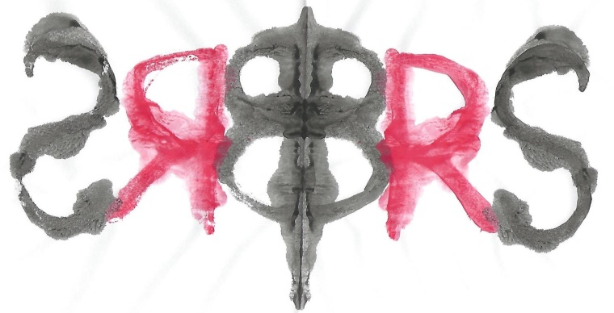
The British Rorschach Society
&
Carstairs Psychological Associates

Offer

Training in the Rorschach Comprehensive System
With Dr Kari Carstairs, BRS President

The aim is to provide participants with a foundation in the Comprehensive system for Rorschach administration, scoring and interpretation. This course will cover the basic information that participants need to start using the test in their practice.

Participants must be qualified psychologists as demonstrated by either Chartered status with the BPS or registered status with the HCPC, or students enrolled in a postgraduate psychology training.

The course will take place over a year, starting in April 2020 and ending in March 2021.
It is designed in four modules:
Module One: Basic Scoring
Module Two: Special scores and more advanced scoring
Module Three: Administration
Module Four: Introduction to interpretation.

The teaching format will consist of on-line lectures that participants can access from their own locations either live or at a time to suit them, followed by face to face meetings, one for each module, to take place in London for three hours on a Saturday. Participants will also be assigned reading from Exner’s 2003 edition of Volume One Basic Foundations and Principles of Interpretation and exercises from the Workbook. All participants will receive individual supervision on one clinical case from their own practice as an integral part of the training.

Total cost £1,300 plus VAT
In addition, all participants will receive one year’s membership in the BRS at no cost.

EARLY BIRD RATE: £1,000 plus VAT for those who pay by 24th January 2020

Student rate £800 + VAT

Dates

Introduction
Face to face Saturday 4th April 2020

Module one Module two

On-line lectures 1pm to 2pm On-line lectures 1pm to 2pm
Monday 20th April 2020 Monday 29th June 2020
Monday 27th April Monday 6th July
Monday 11th May Monday 13th July
Monday 18th May
Monday 8th June Face to face
Saturday 18th July
Face to face
Saturday 20th June

Module three Module Four

One on-line lecture 1pm to 2pm On-line lectures 1pm to 2pm
Monday 7th September 2020 Monday 23rd November 2020
Monday 30th November
Monday 7th December
Face to face Monday 14th December
Saturday 12th September Monday 4th January 2021 Monday 18^{h} January 2021
Participants will administer the test to one Monday 1st February
examinee from their own settings, score it, Monday 15th February
& submit it to be marked by 16th October. Monday 1st March
Individual feedback on scoring and administration
will be provided by Skype to be completed for Face to face
each participant by 16th November. Saturday 27th March 2021

The on-line lectures will be offered live to participants, giving them the opportunity to ask questions. These lectures will also be recorded and posted on the “members only” area of the BRS website so for those who cannot participate on Mondays at 1pm, there will be the option to view the lecture at a later time to suit them.

The venue for the Saturday sessions will be at the offices of Carstairs Psychological Associates in Bromley. The time for the Saturday sessions will be from 10am to 1pm. Attendance at these five sessions in person is required.

All participants will need to purchase:
A set of inkblots from Hogrefe and a block of location sheets
Exner, J. E. (2003). The Rorschach: A Comprehensive system: Volume 1. New York: Wiley.
Exner, J. E. (2001). A Rorschach Workbook for the Comprehensive System: Fifth edition. Asheville, North Carolina: Rorschach Workshops.

