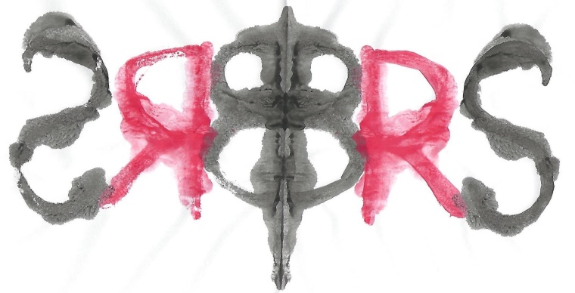

The British Rorschach Society
Invites you to our

Annual Case Presentation

On
Wednesday 26th February 2020
4pm to 6pm
At
151 Wardour Street,
London,
W1F 8WE

One case will be presented from the membership which will provide an opportunity to discuss how the Rorschach data contributes to the formulation and understanding of the examinee’s personality functioning in the light of the referral question. Dr Justine McCarthy Woods, Dr Kari Carstairs and Dr Marc Desautels will provide some preliminary thoughts on the case and then the discussion will be open to the audience.

This event is free for all members of the British Rorschach Society.
Non-members are very welcome to join us and will be asked to pay £10 per person.
Please contact Dr Carstairs to confirm your attendance.

