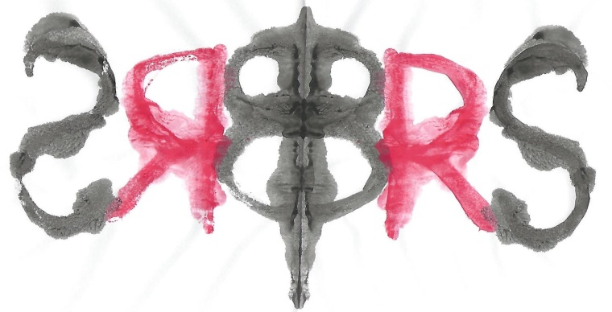
The British Rorschach Society
&
Carstairs Psychological Associates

Offer

Training in the Rorschach Comprehensive System
With Dr Kari Carstairs, BRS President

The aim is to provide participants with a foundation in the Comprehensive system for Rorschach administration, scoring and interpretation. This course will cover the basic information that participants need to start using the test in their practice.

Participants must be qualified psychologists as demonstrated by either Chartered status with the BPS or registered status with the HCPC, or students enrolled in a postgraduate psychology training.

The course will take place over a year, starting in April 2018 and ending in April 2019.
It is designed in four modules:
Module One: Basic Scoring
Module Two: Special scores and more advanced scoring
Module Three: Administration
Module Four: Introduction to interpretation.

The teaching format will consist of on-line lectures that participants can access from their own locations either live or at a time to suit them, followed by face to face meetings, one for each module, to take place in London for three hours on a Saturday. Participants will also be assigned reading from Exner’s 2003 edition of Volume One Basic Foundations and Principles of Interpretation and exercises from the Workbook. All participants will receive individual supervision on one clinical case from their own practice as an integral part of the training.

Total cost £1,250 plus VAT
In addition, all participants will receive one year’s membership in the BRS at no cost.

EARLY BIRD RATE: £1,000 plus VAT for those who pay by 23rd January 2018

Student rate £750 + VAT

Dates

Module one Module two

On-line lectures 1pm to 2pm On-line lectures 1pm to 2pm
Monday 23rd April 2018 Monday 18th June 2018
Monday 30th April Monday 25th June
Monday 14th May Monday 2nd July
Monday 21st May
Monday 4th June Face to face
Saturday 7th July
Face to face
Saturday 9th June

Module three Module Four

One on-line lecture 1pm to 2pm On-line lectures 1pm to 2pm
Monday 10th September 2018 Monday 19th November 2018
Monday 3rd December
Monday 17th December
Face to face Monday 7th January 2019
Saturday 15th September Monday 21st January 2019 Monday 4th February 2019
Participants will administer the test to one Monday 18th February
examinee from their own settings, score it, Monday 4th March
& submit it to be marked by 15th October. Monday 18th March
Individual feedback on scoring and administration
will be provided by Skype to be completed for Face to face
each participant by 15th November. Saturday 6th April 2019

The on-line lectures will be offered live to participants, giving them the opportunity to ask questions. These lectures will also be recorded and posted on the “members only” area of the BRS website so for those who cannot participate on Mondays at 1pm, there will be the option to view the lecture at a later time to suit them.

The venue for the Saturday sessions depends on how many participants sign up. It will either be at the offices of Carstairs Psychological Associates in Bromley if there are five or fewer participants or at the London School of Economics if there are six or more. The training will go ahead regardless of the number of participants. The time for the Saturday sessions will be from 10am to 1pm.

All participants will need to purchase:
A set of inkblots from Hogrefe and a block of location sheets
Exner, J. E. (2003). The Rorschach: A Comprehensive system: Volume 1. New York: Wiley.
Exner, J. E. (2001). A Rorschach Workbook for the Comprehensive System: Fifth edition. Asheville, North Carolina: Rorschach Workshops.

